## Overview

It’s time to put your HTML skills to the test by building a one-page website about your favorite animal or pet.

## Instructions

1. Use the following image as your wireframe and fill it with your content. If you have photos of your favorite pet, use those: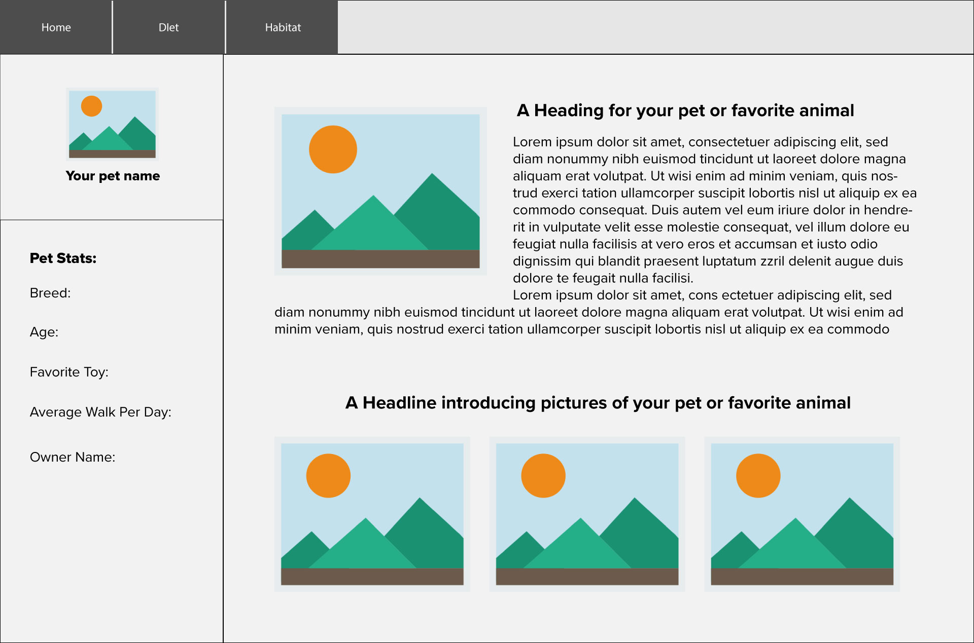

**Note:** Refer to the steps below to get a breakdown of the HTML tags you will use to create your webpage.

**Tip:** Remember to look at previous activities and documentation for hints if you get stuck.

**Step 1: Build the Navigation**

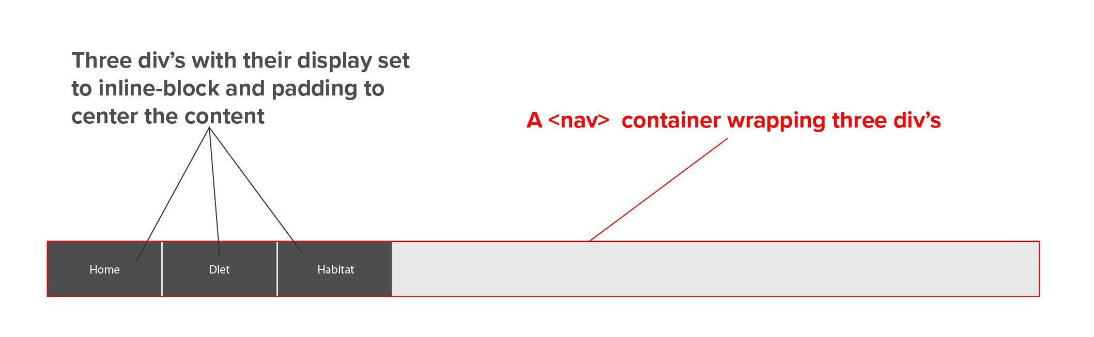

**Step 2: Build the Body Structure**

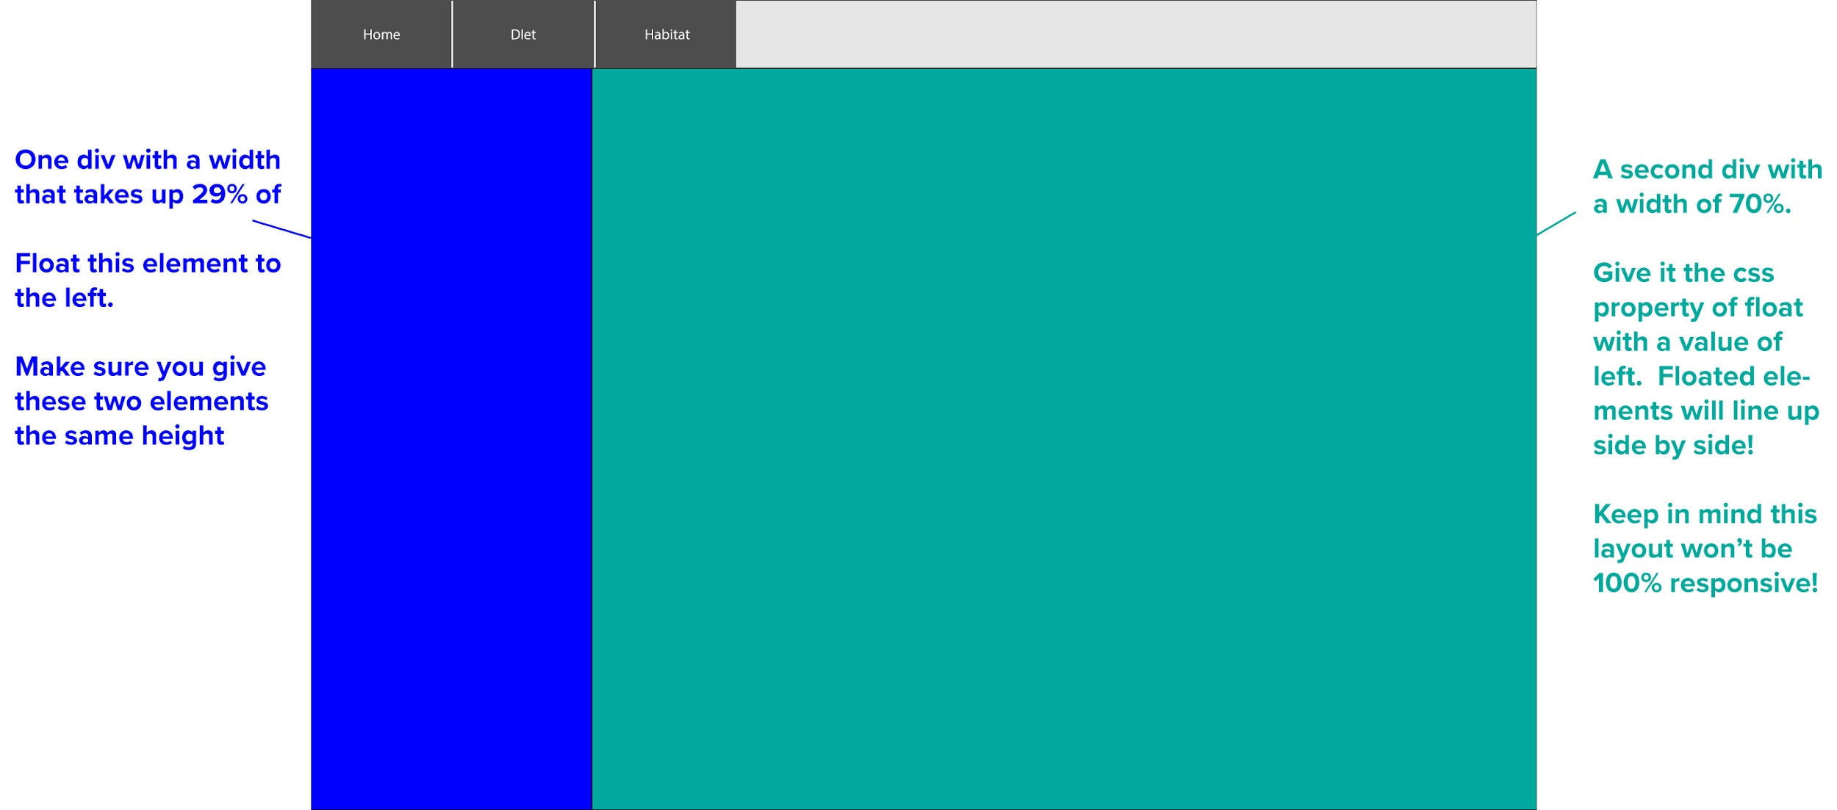

**Step 3: Fill the Left Column**

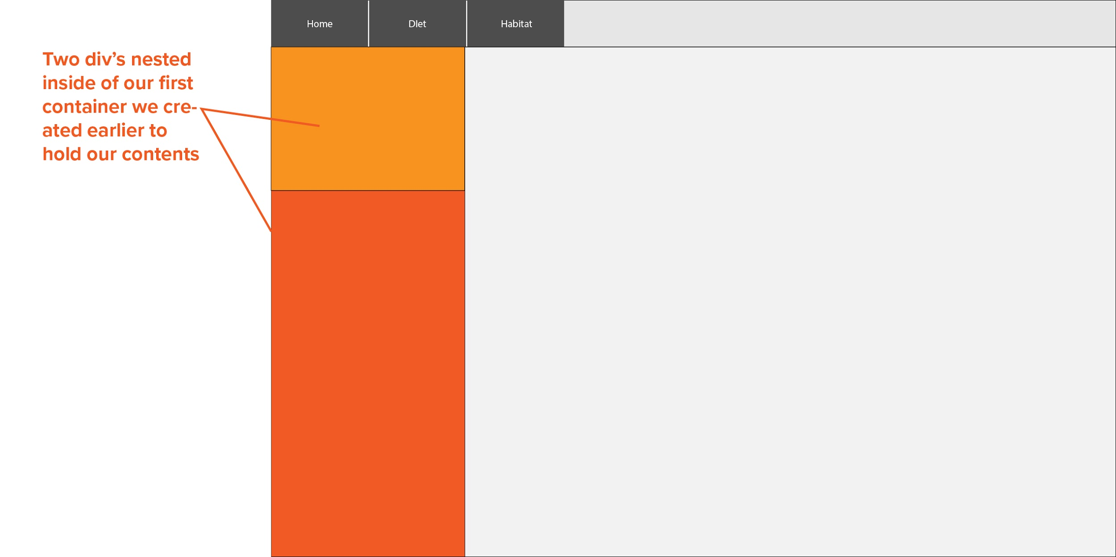

**Step 4: Add and Position Your Content**

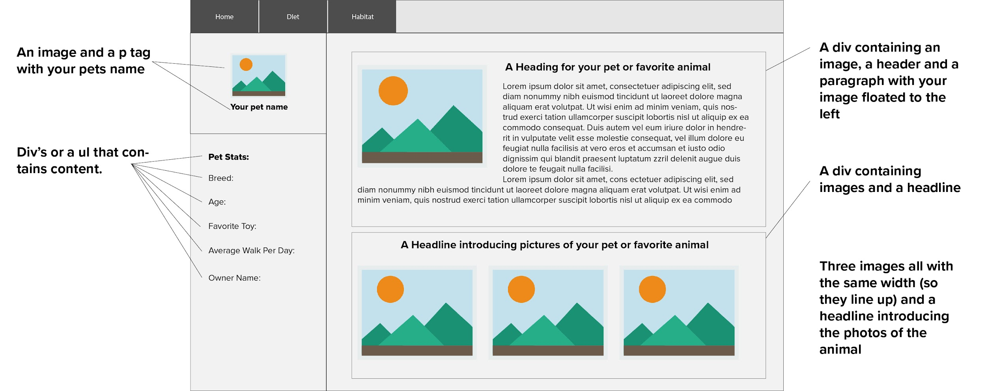

When you finish, post a screenshot of your work to your class’s 01-class-activities channel.